Operating system
TASK 02
Name Nabiha Sabir
Roll no : SU92-BSSEM-S24-019
Section : 4A
Task 1 Write a script that clears the screen and prints “Hello, Welcome to Shell Scripting!”.
code
#!/bin/bash
clear
echo "Hello, Welcome to Shell Scripting!"
Task 2 Write a script that prints the following system information using environment variables: • Your Shell name • Your Home directory • Your Current working directory
#!/bin/bash
echo "Shell Name: $SHELL"
echo "Home Directory: $HOME"
echo "Current Working Directory: $(pwd)"

chmod +x task2.sh
./task2.sh
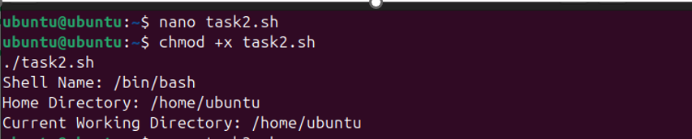
Task 3 Write a script that takes name and age from the user and prints.
#!/bin/bash
read -p "Enter your name: " name
read -p "Enter your age: " age
echo "Your name is $name and you are $age years old."
Task 4 Write a script that takes two numbers from the user and swaps their values.
#!/bin/bash
read -p "Enter first number: " a
read -p "Enter second number: " b

echo "Before swapping: a=$a, b=$b"

temp=$a
a=$b
b=$temp

echo "After swapping: a=$a, b=$b"

Task 5 Write a script that checks whether a number entered by the user is even or odd. dd
#!/bin/bash
read -p "Enter a number: " num

if (( num % 2 == 0 ))
then
echo "$num is Even"
else
echo "$num is Odd"
fi
chmod +x task5.sh
./task5.sh
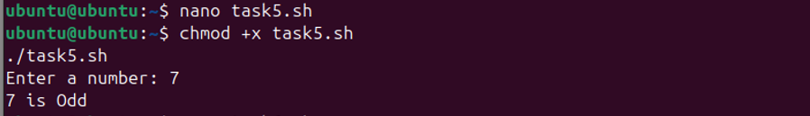
Task 6 Write a script that checks whether a number entered by the user is positive, negative, or zero.
#!/bin/bash
read -p "Enter a number: " num

if (( num > 0 ))
then
echo "The number is Positive"
elif (( num < 0 ))
then
echo "The number is Negative"
else
echo "The number is Zero"
fi
chmod +x task6.sh
./task6.sh
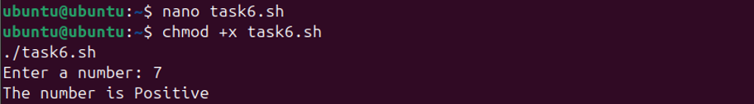
Task 7 Write a script that takes three numbers from the user and prints which one is the largest.
#!/bin/bash
read -p "Enter first number: " a
read -p "Enter second number: " b
read -p "Enter third number: " c

if (( a > b && a > c ))
then
echo "$a is the largest number"
elif (( b > c ))
then
echo "$b is the largest number"
else
echo "$c is the largest number"
fi
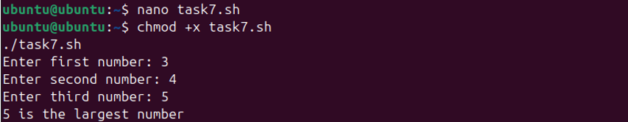
Task 8 Write a script that takes two numbers from the user and performs addition, subtraction, multiplication, and division.
#!/bin/bash
read -p "Enter first number: " a
read -p "Enter second number: " b

echo "Addition: $((a + b))"
echo "Subtraction: $((a - b))"
echo "Multiplication: $((a * b))"

if (( b != 0 ))
then
echo "Division: $((a / b))"
else
echo "Division not possible (b = 0)"
fi
chmod +x task8.sh
./task8.sh
